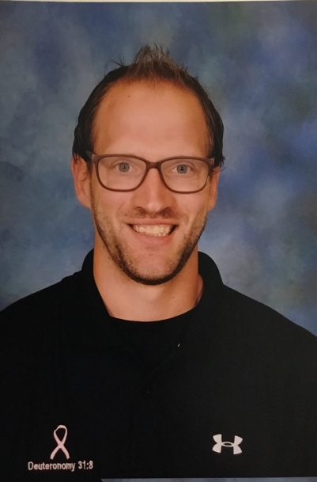
Shaun Belcher
469-442-8509

shaunbelcher31@gmail.com

6115 Jack Finney Blvd
Apt K7
Greenville, Texas
75402

Testimony
It all started in 2001. It was the same Wednesday night like every night; go to school, then go to church as my mom drops me off at Berean Baptist Church in Mesquite, Texas. All of a sudden during the lesson, I heard a voice saying Shaun “listen to me, I have come for everyone, but tonight you are mine.” After, the service I went to Kelly Reagan who was the children’s pastor at the time. He pulled me in the gym and went down the Romans Road with me in that moment I accepted that I was a sinner, and accepted Jesus Christ in my heart at the age of eleven years old. Later, when I went to a winter camp at Baptist Bible College at the age of fourteen. Brian Moore the guest speaker was talking about the whole week to work on team Jesus. He spoke about how there is more to do for Jesus than just being saved. That moment on a cold Wednesday night in the Boland Hall I surrender my life to full-time ministry. The second best decision in my life when God brought my wife, Jennifer to my life. We met during our time at BBC. We got married on June 8, 2013. Since then we now have two boys: Lincoln (3) and Duke (born in 2017). We recently just adopted a lab mix puppy name Bear. I graduated Baptist Bible College in 2014 with a bachelors degree in Pastoral Studies. Currently I am the youth pastor at the church at River Oaks in Greenville, Texas. My motto for the youth is “You’re not just kids, you’re Leaders.” That is something I believe in, by having a student leadership team and giving them jobs in the church to show what serving looks like.

Ministry Objective
To serve students and their parents to grow, and make disciples for the Kingdom of God.

Ministry Philosophy
Working with teenagers is a honor and privilege. To see them serving and engaging in the church body is very rewarding. The goal for my youth ministry is that every student would be accepted, and be a servant in the local body, then in the local community, and then finally rest of the world. Students will grow and be discipled in away that will honor God and be the best world changers for the cause of Christ.

Ministry Experience
First Baptist Wylie
- Internship 2011
Crossway Baptist Church 2013-2014
- Internship
- Youth Volunteer
Church at River Oaks
- Volunteer October 2016 – August 2017
- Middle School Pastor August 2017- December 2017
- Student Ministry Pastor January 2018- Present
I have led the middle school youth, and the youth ministry as a whole. I brought ideas for guests, student leadership, even decorating our new youth room! I have helped the Pastor and Family Life pastor organize church events and help see the plans through for our city wide mission project called For the City where our church leads the Food drive. I have spent this time encouraging and leading the students showing them a life of serving all while planning out events for the year, picking a camp to attend, and attending important events in their lives.

Education
Mesquite High School

Wylie High School, Wylie, Texas

class of 2009
Baptist Bible College, Springfield, Missouri
- class of 2014
- Bachelor in Pastoral Studies

Work Experience
Lighthouse Lanes 2010-2013
Batteries Plus 2013-2015
Bass Pro Shops 2015-2016
Whataburger 2016-2017
Royse City ISD 2017- Present
- Paraprofessional in Life Skills at Miss May Vernon Elementary
Providence Christian Academy 2017-Present
- Extended Care

Skills
- Communication
- Creativity
- Goal setting – Goal reaching
- Encouraging

References
Dustin Byrd 409-960-4503
Jerry Sadler 903-274-7608
Brandy Davis 214-794-1253

